|  |  |  |  |  |  |  |  |
| --- | --- | --- | --- | --- | --- | --- | --- |
| OpenreachLogo_Purple | |  | | --- | | ISIS practice  For BT people & Contractors | | EPT/ANS/A010 | | Issue 21, 03-Oct-2019  Use until 03-Oct-2020 | | Published by Technical Documentation - Openreach | | Privacy- None | | |
| Specification for Poling Work | |  |
| Provision, Renewal, Recovery of poles within the Openreach Access Network | |  |

About this document ...

Author

The author of this document may be contacted at:

|  |
| --- |
| Martin Nottage |
| Working at Height & PPE Professional |
| Openreach (BOI) |
| Post Point G32, PolarisPolaris House  Adastral Park  Martlesham Heath  Ipswich  SUFFLK  IP5 3RE |
|  |
| Telephone: +441473642254 |
| Fax: |
| Email: martin.nottage@openreach.co.uk |

Content approval

|  |
| --- |
| This is the Issue 21 of this document. |
| The information contained in this document was approved on 03-Oct-2019 by Glen Barford, Overhead Network Policy and Standards Specialist |

**Version History**

|  |  |  |  |
| --- | --- | --- | --- |
| Version No. | Date | Author | Comments |
| Issue 21 | 03-Oct-2019 | Martin Nottage | Changes to sect 4.1.6 – removal of use of alternative preservation poles. |
| Issue 20 | 21-Jun-2019 | Martin Nottage | Upissue & author change only |
| Issue 19 | 29-Jun-2015 | ISIS co-ordinator . | Update to sect 4.21. Added hyperlinked e.mail address. poleupdate@bt.com |
| Issue 18 | 03-Mar-2015 | Document Manager T | Document migrated onto new platform with no content change |
| Issue 18 | 18-Feb-2015 | ISIS co-ordinator . | Requirements for Wireless Poles added at Section 5. |
| Issue 17 | 26-Mar-2014 | Chief Engineer's Office Technical Documentation Team | hessian sack provider details updated (AT306) |
| Issue 16 | 15-Jan-2014 | Chief Engineer's Office Technical Documentation Team | updates to sect 4.21 ext file, 4.1.2 url, 4.1.5 url, 4.1.9 NRI ref removed, 4.18 updated, sect 5 appendices normalised (AT 285) |
| Issue 15 | 16-Jul-2013 | Chief Engineer's Office Technical Documentation Team | Update to details for restricted depth poles, and inclusion of reference for TDFS (Section 4.18) |
| Issue 14 | 22-Nov-2011 | Chief Engineer's Office Technical Documentation Team | 4.1.6 incorrect bullet left in, text removed (DCC1444 AT) |
| Issue 13 | 18-Nov-2011 | Chief Engineer's Office Technical Documentation Team | section 4.1.6 & 4.1.7 corrected with regards to placement of, but no change to the actual text (DCC 1444 AT) |
| Issue 12 | 10-Oct-2011 | Chief Engineer's Office Technical Documentation Team | Document reviewed.Para. 4.19 revised - removal of reference to High Load Routes. (AEI/AEC/B042) (DCC1317PD) |
| Issue 11 | 5-Oct-2011 | Chief Engineer's Office Technical Documentation Team | Document reviewed.Para. 4.21 revised to include Environmental Regulations/AEC B039. (DCC1253PD) |
| Issue 10 | 20-Sep-2011 | Chief Engineer AEI Technical Documentation team | Removal of Hollow Pole Gas seal requirement |
| Issue 9 | 27-Apr-2010 | Chief Engineer AEI Technical Documentation team | Update to Section 4.2.4. DCC770/SH. |
| Issue 8 | 10-Sep-2009 | Chief Engineer AEI Technical Documentation team | New section 4.2 Revision to low wire policy. Also amendment to section 5.2 drawing of lagged pole DCC202 |
| Issue 7 | 7-Jul-2009 | Chief Engineer AEI Technical Documentation team | Document reviewedPara. 4 revised - Inclusion of new guidance regarding correct choice of pole guage. (DCC266) |
| Issue 6 | 20-Feb-2009 | Chief Engineer AEI Technical Documentation Team | Inclusion of ESM 35/2008 and change of author & Approver |
| Issue 5 | 8-Sep-2008 | Paul Downes | Para 2.1 - UPB Glossary description revised. |
| Issue 4 | 25-Jun-2008 | Paul Downes | Update to para. 2.1 - Description of UPB. |
| Issue 3 | 20-Jun-2007 | Paul Downes | Update to para. 2.1, 4.1.3, 5.8 following introduction of alternative preservative poles |
| Issue 2 | 7-Jun-2007 | Paul Downes | Update to para. 4.8.1 - Pole Steps |
| Issue 1 | 28-Feb-2007 | Paul Downes | Launch |
| Issue Draft 0a | 26-Feb-2007 | Keri Thomas | New document |

Table of Content

1 Introduction 5

2 Glossary 5

2.1 Terms 7

3 General Description of the work to be carried out 7

4 Requirements 8

4.1 Provision and Renewal of Poles 8

4.2 Pole handling 19

4.3 Span length limits 20

4.4 Location of Other Utilities 20

4.5 Provision of a Testing Earth on Poles 20

4.6 Power clearance 21

4.7 Insulators 21

4.8 Pole furniture & fittings 21

4.9 Route/pole strengthening 23

4.10 Recovery of an Existing Strut 25

4.11 Temporary Staying of Route 26

4.12 Pole holes 26

4.13 Pole depths 26

4.14 Other Exceptions to Standard Depth – Restricted Depth 34

4.15 Pole depth verification 35

4.16 Pole alignment & orientation 35

4.17 Reinstatement 36

4.18 Possible Technical Departures From Standards (TDFS) 36

4.19 Statutory notices 36

4.20 Marking and Labelling of Poles 36

4.21 Registration of New Poles 37

4.22 Storage and Disposal of Poles 38

4.23 Operating instructions 38

4.24 Product approval 38

5 Requirements for Wireless Poles 39

6 Appendices 39

6.1 Appendix 1 - Universal Pole Bracket (UPB) 39

6.2 Appendix 2 - Lagging of Existing Poles in the Event of Bleeding 39

6.3 Appendix 3 - Rings Polehead Dropwiring 41

6.4 Appendix 4 - Step Positions on Pole 42

6.5 Appendix 5 - Hollow Pole Caps and Collars 43

6.6 Appendix 6 - vertical definition & permitted tolerances 44

6.7 Appendix 7 - hollow pole orientation 45

6.8 Appendix 8 - Preservative Treatments - Code Markings 46

# Introduction

This Document forms part of the Access Network Specification range of ISIS Documents and is applicable to both Openreach Direct Labour and External Contractors.

The information below details the performance requirements for the provision, replacement and recovery of Poles within the BT network. Practices and items of plant are only detailed where necessary to ensure BT's Network and plant is not compromised.

1. The specifications for attachments to Poles, ie Dropwires, Aerial Cables, Stays etc, are covered in other Documents in the range. See EPT/ANS/A001 for an index of all Access Network Specifications.

# Glossary

* Products

|  |  |
| --- | --- |
| Item | Description |
| Banding Stainless Steel | (Item Code 013610) Stainless steel strip banding 20mm x 0.7mm x 50 metres. It is contained in a plastic "Easy carry container". Used in conjunction with a Universal Pole Bracket (UPB), as the preferred method of attaching Aerial Cables to Wooden Joint User Poles where a Power down cable exists on the Pole. Can also be used as an alternative method of attaching Aerial Cables & Stays to BT Steel Hollow and Wooden Poles. |
| Cap Pole 1A | (Item Code 016277) A mushroom shaped Glass Reinforced Plastic moulding. Fitted to the top of a Hollow Pole to provide a smooth entry / exit point for wires and cables. |
| Clip Banding Stainless Steel | (Item Code 013603) Used in conjunction with Banding Stainless Steel and Tool to fix Universal Pole Bracket (UPB) to Poles. See Banding Stainless Steel & UPB for details. |
| Collar Hollow Pole 2 | (Item Code 016318) A hinged metal bracket. Fitted near the top of Hollow Poles to facilitate the fitting of a Stay or Aerial Cable. |
| Conduit 20 | (Item Code 014808) A Plastic conduit supplied in 2.3m lengths. To be installed in accordance with the specification down the sides of Poles to enable retrospective confirmation of Pole depth. |
| Hollow Pole | (Item Code – Various, depending on size / class) Alternative to wood Pole. Currently available in Galvanized Steel, previous versions include Stainless Steel & Glass Reinforced Plastic (GRP). Typically used in Hazardous situations. |
| Insulator Stay No 2 | (Item Code 012501) Glazed earthenware insulator designed to take compressive loads between its two eyes. Used to isolate BT plant from Power |
| Pins Steel No 1 | (Item Code 073204) Steel Pins used to attach Pole Numbers to wooden poles. |
| Plugs Conduit 20 | (Item Code 014809) Plastic plug. To be fitted at top & bottom of Conduit 20 to prevent ingress of debris |
| Pole Numbers | (Item Code - Various) For Wood Poles - A range of Plastic numbers. To be fixed to Poles using steel pins to enable pole identification.  For Hollow Poles – As above but labels are Self-Adhesive. |
| Ring Pole Head Dropwire | (Item Code 121240) 2 Piece Galvanized steel ring with connecting nut & bolt. This is a current standard fitting used to support the feed cable (Dropwire) at the Pole top. |
| Screws Coach | (Item Code 014700) Galvanized steel screw. Used to fix Steps to Wood Poles |
| Soil Stabilizing Agent 12.5KG | (Item Code 025143) A soil stabilizer. For use in backfilling Pole surrounds when the excavated spoil is too wet to compact. |
| Stay Guard High Visibility | (Item Code 013612) A Solid Yellow split tube which requires no tools to aid installation. Used to mark Staywires attached to BT Poles to make them highly visible. |
| Steps Pole No 1 | (Item Code 015550) Galvanized steel step has a fixing hole on each side level with the tread, and one at the lower end of the strut. To be fitted to wood poles in accordance with the Specification (not required on Hollow Type Poles) |
| Tool Fixing Stainless Steel Banding | (Item Code 013608) Used in conjunction with Banding & Clip Banding Stainless Steel to fix Universal Pole Bracket to Hollow Poles and Joint User Poles. |
| Type 1 Granular Sub Base | (Item Code 024951) A Granular Sub Base. Used as an alternative backfill material around Poles. See also Soils Stabilizing Agent 12.5KG. |
| Universal Pole Bracket (UPB) | (Item Code 016988) The UPB is made from a high strength corrosion resistant aluminium alloy. Its dimensions are 120mm x 114mm x 46mm. For further information on port loadings/configurations, refer to ISIS EPT/ANS/A012 – Specification for Aerial Cabling. |
| Wood Pole | (Item Code – Various) Preferred Pole Type. Two Classes currently used are Light & Medium. Available in various sizes from 6m to 15mtr (depending on class) |
| 10m Medium Pole Alternative Preservative | (Item Code 037963) Wooden pole treated with alternative preservative for use in previously restricted locations, namely schools, parks and playgrounds. |
| 9m Light Pole Alternative Preservative | (Item Code 037964) Wooden pole treated with alternative preservative for use in previously restricted locations, namely schools, parks and playgrounds. |

## Terms

|  |  |
| --- | --- |
| Block / Blocking | Obsolete method of providing pole / route stability |
| Depth of Pole | The depth that a pole is set in to the ground. |
| DNO | Refers to the Power Distribution Network Operator. (Formally Regional Electricity Company) |
| Obsolete | Within this Document, the term OBSOLETE refers to Products / Practices which have been withdrawn and which are no longer authorised for use in the Network. |
| Obsolescent | Within this Document, the term OBSOLESCENT refers to Products / Practices which although Outdated / Superseded, are currently still authorised for use in the Network. |
| SA | Specification Authority (Openreach Network Capability & Development) |
| Scrap Pole/s | Poles that are no longer fit for use within the BT network and cannot be re-used. |
| Stay | Current method of providing Pole / Route stability |
| Strut | Obsolete method of providing Pole / Route stability |
| Testing Earth Wire | A Copper wire run down from the top of the Pole and wound round the base of the Pole (wood poles only) to facilitate testing. Not to be used for Lightning Protection work |
| Works Executioner | The Person / Organisation undertaking the work |
| Works Originator | The Person / Organisation Planning / Designing / Issuing the work for execution |

# General Description of the work to be carried out

Pole Installation and Recovery

Provide, replace or recover any specified wooden or hollow pole, in its present or any other location as required by the Work Originator.

Pole Dressing

Provide, replace or recover any or all pieces of pole furniture as required by the Work Originator.

Excavation

Carry out all necessary excavations in connection with this specification, to remove and dispose of all excess spoil from the site.

Reinstatement

Carry out reinstatement as detailed elsewhere in this specification.

# Requirements

## Provision and Renewal of Poles

New pole/s shall be of the correct size and type for the specific site circumstances. See EPT/ANS/A011 for details of Pole Loadings / Load Categories.

The replacement Pole/s should be positioned wherever possible in the same location as the pole being recovered.

The new Pole shall be positioned such that a full Pole Test can be carried out.

Hollow poles in need of replacement must be replaced with a similar hollow pole (where a hazard still exists). Exceptionally, in situations where in order to obtain minimum wire height, the required Pole size is greater than that provided by the largest available hollow pole (10mtr), a wooden pole may be used.

In such cases, a Request Test must be raised via the AAPO to ensure an 'H’ label is affixed by an Openreach Pole Tester (the only person allowed to attach testing labels to poles). The request test must be submitted as soon as the work is executed.

The preferred hierarchy of solutions is as follows:

|  |  |  |
| --- | --- | --- |
| Option | Solution | Possible Issues |
| 1 | Move the pole to a new location, beyond 1m from the existing hazard, continue with a wooden pole | Cost.  Wayleaves.  Additional ductwork/civils required. |
| 2. | Replace the pole in it’s existing location with a hollow pole | Poles only available in sizes 9 & 10 metres.  Wire height issues.  Pole loading. |
| 3. | Replace the pole in it’s existing location with a wooden pole, and seek request test to re-classify pole as H | Should only be a last resort, as pole will continue to require platform access |

Any required changes to design shall be agreed with the Works Originator / Designer and recorded.

### Correct Pole Choice for Circumstances – Light or Medium

The loading capabilities for DPs on light & medium vary according to the particular location. Poles in denser urban areas can take a higher dropwire loading as they are not subject to the highest wind loadings.

This is detailed in full in ISIS EPT/ANS/A011 along with guidance on how to determine the loading for any particular location. The table (i) giving the maximum loading is detailed below:-

TABLE (i) – MAXIMUM DROPWIRE LOADINGS

|  |  |  |  |
| --- | --- | --- | --- |
|  |  | Maximum Number of Wires | |
| Category | Type of Distribution Point | Light Poles | Medium Poles |
| 1 | Urban – terraced houses/apartment blocks | 40 | 40 |
| 2 | Urban – semi detached houses | 28 | 40 |
| 3 | Semi rural DP’s. Houses reasonably spread | 24 | 40 |
| 4 | Rural DPs | 20 | 30 |
| 5 | Exposed rural | 12 | 20 |

From the above table, it is clear that in the majority of cases, for poles with only dropwire loads, then a ‘light’ pole will suffice.

The only other consideration is when the pole has loading only to one side, or wires within a limited arc. The guidance on this is as follows:-

### Poles with non-radial loads

(from ISIS EPT/ANS/A011)

Where feeds are necessarily concentrated on one side of a pole the following limitations will apply:-

* On light poles, no more than 7 dropwires should feed from a pole within a 180 degree arc and no more than 4 within a 30 degree arc.
* On medium poles, no more than 15 dropwires should feed from a pole within a 180 degree arc and no more than 5 within a 30 degree arc.
* Dropwires of similar spans and of nominally 180 degree spacing may be excluded from the above limitations i.e dropwires that balance one another need not be considered in the above conditions. (From ISIS EPT/OHP/B011)

NEWLY PLANNED DPs

When planning new DPs, consideration should be given to the likely maximum future dropwire count, when determining whether to use a ‘Light’ or ‘Medium’ pole.

Obviously, if it is planned for the pole to carry aerial cables, or there is a genuine possibility of this in the future, or the pole is ‘one side loaded’ then a ‘medium’ pole should be used.

CARRIER POLES

When carrier poles are provided simply to give clearance for dropwires crossing roads (usually for bungalows, low buildings etc) then in virtually all cases a ‘light’ pole will suffice.

POLE HEIGHTS & CARRIAGEWAY CLEARANCE

It is important that the correct height of pole is used where wires / cables will be crossing the carriageway, and it may be useful to use the wire height calculator, on-line examples of which can be found at the [AEI sharepoint site](https://intra.bt.com/bt/openreach/our-organisation/service-design/chief-engineer/network-evolution/interface-team/organisation-network_reliability_home_page/aei_library/Pages/index.aspx) or use url   
(https://intra.bt.com/bt/openreach/our-organisation/service-design/chief-engineer/network-evolution/interface-team/organisation-network\_reliability\_home\_page/aei\_library/Pages/heightcalculators.aspx)

COMPLIANCE CHECKS

As part of the audit regime, checks will be carried out to ensure the most appropriate pole gauge has been used, for the particular circumstance.

For planned works, checks will be carried out to ensure the work has been completed in line with the original agreed planned solution, and / or that any changes have been agreed with the planner.

For Asset Assurance work, checks will be carried out to ensure that the most appropriate size has been both specified and used for the particular circumstance.

Defects will be raised for non-compliance.

### Pole positioning considerations (new & replacement poles)

Where a Pole is to be provided / replaced in Verge, Footway, Kerbed areas, the following considerations apply:

* The preferred position for Poles is on the Property boundary side of the Footway. (See "B" in Figure 1)
* Wherever possible / practical, a minimum of 1 metre clearance should be maintained in the footway for pedestrian access. (See decision table below)
* Wherever possible, on made up Footpaths or Grass Verge, the Pole position should be a minimum of 500mm from the Kerb Stones or other edges (See "A" in Figure 1). On very wide footpaths this may be increased depending on the position of other utilities.

1. The 1m Footway clearance takes precedence over this requirement.



Figure 1:

A = Minimum Distance for Pole from kerb edge

B = Preferred Pole position for Poles in Footway

1. X = 500mm

Decision Table – 1m Footway Requirement

Existing Poles

|  |  |
| --- | --- |
| Situation | Solution |
| Existing Pole Position provides Min 1m Footway clearance | Renew in same position  \*Note: Consideration must also be given to RTA Requirements (see below) |
| Existing hole does not provide 1m clearance but suitable alternative position available with 5m | Renew Pole in new suitable position |
| Existing hole does not provide 1m clearance but suitable alternative position available with 10m | Agree DFE with AAPO for up to 5m of additional duct and renew Pole in new suitable position |
| Existing hole does not provide 1m clearance and no suitable alternative position is available with 10m | Contact AAPO for Authority to:  a) Erect with <1m Footway clearance (Slip Number required)  or  b) Provide Non Standard Solution |

New Poles

|  |  |
| --- | --- |
| Situation | Solution |
| Min 1m clearance achievable | Provide Pole in suitable position |
| No suitable location available which will provide 1m clearance | Contact Openreach Works Originator |

#### Additional considerations

Consideration should also be given to the following aspects which may impact on the Pole in future:

* Ladder Positioning
* Pole Testing
* Access by Elevating Platform
* Surface reinstatement requirements following Pole Testing
* Increased likelihood of damage by tall vehicles where Pole is located close to carriageway edge, particularly where significant road camber exists.

### Pole positioning considerations (rta renewals)

* Where, following site survey, the existing Pole position is deemed to be in a vulnerable position it should be re-positioned to a safer position away from the carriageway. (See decision table above).

### Revised Working Procedures for Poles Involved in Road Traffic Accidents (rtas)

Although not actually detailed in any AE&I practice ISIS document, it has become ‘custom & practice’ for all poles involved in RTAs to be renewed. A technical review has determined that this approach is wholly inappropriate, and that the decision to renew the pole should be based on a combination of the extent of the damage, and a full test & inspection of the pole.

The principle is that if there is ANY damage, and we can recover the cost, we will renew the pole. This is appropriate, as there is potential for minor damage to shorten pole life, although this may not be apparent at the time. However, such minor damage will not make the pole unsafe to climb or to continue in service. If the costs are not recoverable, then we will examine the pole and make the decision accordingly

Process for "first person on site" or discoverer of RTA damage

There is considerable existing guidance in e-assistant on dealing with RTA damage. All of the existing guidance regarding on site Risk Assessment, making the site safe, reporting/liaison with emergency services etc. remains exactly the same.

In eAssistant under Damage to BT Property or Plant  
<http://openreach.informe.intra.bt.com/eassistant/v2/network/damage/damagebt.htm>  
see  [here](http://openreach.informe.intra.bt.com/eassistant/v2/network/damage/damagebt.htm#traffic) and [here](http://openreach.informe.intra.bt.com/eassistant/v2/network/damage/damagebt.htm#smash)

The only process change is with regard to whether the incident requires a pole request test, and whether it should lead to a pole renewal activity.

In the first instance, refer to the table below, to determine the course of action.

|  |  |  |  |
| --- | --- | --- | --- |
|  | Pole definitely has NO evidence of damage | Some evidence of damage, but probably within limits | Damaged beyond limits |
| Details of damager are available, and have been recorded in line with process | See Step 1 for pole examination guidance.  IF no damage is confirmed - No further Action | Arrange for pole renewal, with costs charged to appropriate HL estimate | Arrange for pole renewal, with costs charged to appropriate HL estimate |
| Details of damager are NOT available. | See Step 1 for pole examination guidance.  IF no damage is confirmed - No further Action | GO to Step 2 below | Arrange for pole renewal, with costs charged to appropriate HDU estimate |

Step 1

Examine the pole:- if it is leaning beyond limits, is damaged beyond limits set out in pole test guidance, aerial cables are disconnected or damaged, or the pole is broken, splintered or on the ground proceed with a request for attendance by a pole team, as detailed in existing guidance - END

However, if the pole is still upright, not broken, and no aerial cables are disconnected or damaged, carry out a full pole examination, as detailed in EPT/OHP/C022 or the HSH. If there is evidence of damage, go to Step 2

Step 2

Contact the Pole Request Test Field Support Office,

* 0800 0858262

They will offer guidance on how to verify the condition of the pole, and only if necessary, arrange for a pole tester to visit site.

Step 3

If the pole examination (either by pole tester or by "first person on site") confirms that pole renewal is not necessary, then no further action is required.

If it is determined that the pole is damaged beyond limits, or some damage and the damager’s details are available, and renewal is required, continue with the existing process regarding contacting Damage Duty and arranging for a Pole Team to attend.

Guidance for Poling Teams

If Poling teams are called to an incident with a request for a pole renewal following an RTA, then the assumption is that the above process has been followed and the pole definitely requires renewal.

### Restrictions on the Use of Creosote Treated Poles

There are restrictions on the locations where creosote treated poles can be used.

Openreach’s current range of creosoted wooden poles CANNOT be used within school playgrounds, play areas or other places where children will congregate. The restriction also applies for pole replacement either for uplift works, or Asset Assurance renewal program works. The alternative options available are:

* Use of a hollow pole, available in 2 classes (Light & Medium). A hollow pole should be suitable unless heavyweight aerial cable is being deployed.
* Provide the service UG, or by surface cable on wall or similar, if this is deemed to be the most cost effective solution.

If any job in such a location does not specify a hollow pole, the job should be referred back to the appropriate Control, and the Line Manager advised. If there is doubt as to whether a location should be classified as a school or public playground, consult your Line Manger in the first instance.

It is imperative that the correct poles are used in the restricted circumstances, and auditors will check to ensure compliance. Use of ordinary creosoted poles will be a 10pt CD, and it will be necessary to return to remove and replace any poles incorrectly installed.

### Revisions to Low Wire Policy and Standards

This section details a change to the permitted height standard for drop wires and aerial cables and aligns the policy for all types of work. It details instances where it is permitted to raise a Cat 4 A1024 for wires between 5.5m & 5.9m. There is no change for Openreach volume teams.

Under existing rules, Volume engineers can provide new dropwires at heights between 5.5m & 5.9m, provided a Cat 4 A1024 is raised, to avoid a pole renewal. The principle behind this is that the height variance between 5.5m & 5.9m is an economic issue only, and not a matter of safety or compliance with the Comms Code 2003.

Installation of a new dropwire at between 5.5m and 5.9m is non-compliance to the agreed Openreach installation standard. Such instances are recorded as a Cat 4 A1024 in order to allow compliance to the standard to be monitored. It also affords the opportunity for audit visits to be carried out to ensure that such non-compliances only occur out of necessity and do not occur where the full standard could have been achieved.

This option has NOT been open to either Complex teams, or Contractors, when working on Low Wire retension & refix, pole renewal or new provision work. The principle being that as we are undertaking a poling job, we should ensure that dropwires are at 5.9m and aerial cable is at 5.6m

A detailed analysis of both completed jobs, and jobs in the pipeline (post survey) has shown that a considerable number of jobs either lead to a Non Standard Solution (NSS) or to multiple carrier or intermediate poles, as well as a DP renewal.

(NB – NSS jobs can include ductwork and under-grounding of some or all of the network, to complete the job)

The purpose of this change is to prevent the provision of single poles, very tall poles (13 & 15 Metre), multiple carrier poles or NSS if they are to solely achieve 5.9m for wires and cables

Therefore it will NOT be required to do any of the following actions if they are to solely achieve 5.9m rather than 5.5m

1. Renew a pole rather than use a retension & refix solution (retension, refix, renew or re route).
2. Provide additional carrier poles
3. Provide poles taller than 11m – This is the preferred maximum height.
4. Use Non Standard Solutions (NSS)
5. If in any instance 5.5m cannot be achieved, then the appropriate solution must be chosen in accordance with the Low Wire Height policy prioritisation flowchart

Where 5.9m cannot be achieved, the best possible wire height of 5.5m or above must be provided.

The use and relocation of standard brackets e.g. Eyebolts, Bracket 22 or Bracket 32 should be deployed to achieve 5.9m.

It is essential that Cat 4 A1024s are raised where wires are provided or renewed between 5.5m & 5.9m as failure to do so will constitute a quality defect.

If a wire or cable is provided or renewed between 5.5m and 5.9m, when the full 5.9m installation standard could have been achieved with the solution selected from the Low Wire height policy prioritisation flowchart, this will constitute a quality critical defect regardless of whether an A1024 is raised.

Where a height of 5.5m or above can be achieved using standard brackets e.g. Eyebolts, Bracket 22 or Bracket 32, there is no requirement to fit a Bracket 44 to increase that height.

If clearance of 5.5m cannot be achieved using standard brackets, then a Bracket 44 should be deployed to enable clearance of 5.5m minimum, with customer agreement

An increased pole height up to 11m should be considered if a Bracket 44 cannot be used.

1. The rules regarding wires below 5.5m will be rigorously enforced, and the appropriate defects will be issued.

* LOW WIRE HEIGHT POLICY PRIORITISATION FLOWCHART

All Overhead work on dropwires and aerial cables must be completed in accordance with the priorities in the following flowchart:-

**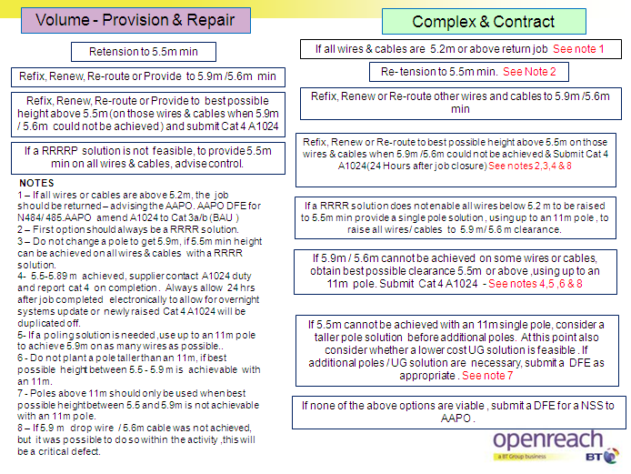**

Additional Low Wire Programme Notes

Note 9 - Installation Standard

The default installation standards over carriageway remain at 5.9 metres minimum for Dropwires and 5.6 metres for Aerial Cables. These standards should always be achieved wherever possible.

Note 10 – Non Compliance for wires or cables erected at 5.5 metres or above

Erecting or renewing a dropwire or aerial cable to between 5.5 & 5.9 metres is non-compliance to the installation standard. This must only be done as an expedient to avoid unnecessary additional expenditure and in accordance with the low wire priority flowchart. This must always be recorded as a Cat 4 A1024 using the appropriate contact method. The new cat 4 A1024 must not be raised before the issued Cat 1 /2 has been made "engineering complete" overnight to allow for systems updates.

Note 11 – Low Wire rectification Programme

The purpose of the low wire rectification programme is to correct all Cat 1 & 2 low wires. Cat 3 & 4 low wires should be raised in conjunction with these but no additional expenditure should be incurred, specifically no additional poles should be erected or civil engineering work carried out for the express purpose of correcting Cat 3 or Cat 4 low wires

### Instances where 5.5m cannot be Achieved, with a Single Pole Solution

There will be occasions when with a single pole solution up to 11m, it is not possible to achieve 5.5m and in those instances a taller pole should be considered first.

If this is not possible the following priority should be followed:-

* Whether a lower cost UG solution is feasible.
* Consider a 2 pole or multiple pole solution
* Lastly, a Non Standard Solution (NSS) may be required.

In ALL of these instances, follow normal AAPO processes for additional work authorisation.

* Planning Poling Solutions For "New Work" – Non Asset Asurance

The principles detailed in this memo apply equally to ‘new’ network provision work, where a poling solution is being provided. Work can be planned to achieve 5.5m, if meeting 5.9m would require additional poles or NSS. This should be done in accordance with the Low Wire Policy priorities.

The Works Executor must contact the Work Planner, if it is considered that additional work is required to achieve the standard

### Guidance for Quality Checkers & Auditors

* Correct heights have been achieved on all wires for the prioritised solution completed.
* 5.9M was achieved when it was possible to do so.
* Correct use and reuse of fixing brackets to achieve required height
* Cat 4 A1024 submitted when a wire or cable was erected between 5.5m and 5.9m

### Summary

* Return AA jobs that have no wires or cables below 5.2m
* Do not use the following solutions to simply achieve 5.9m, as opposed to 5.5m.
* Renew a pole rather than use a retension & refix solution.
* Provide additional carrier poles
* Provide poles taller than 11m – This is the preferred maximum height.
* Use Non Standard Solutions (NSS)
* A Cat 4 A1024 must be raised in ALL cases, for each pole where wires are provided or renewed between 5.5m & 5.9m.

## Pole handling

Care shall be taken during Transporting & Handling to prevent damage. See details below.

### Hollow poles

* When hollow poles are being transported they should be protected from contact with any metal surfaces or tools.
* Hollow poles must be transported so as to prevent damage or marking, particularly creasing or marking from creosote or other materials. Damaged poles must not be erected.
* If mechanical means are employed for lifting or erecting hollow poles, steel or wire rope slings or chains must not be used.

### Wooden poles

* Only poles supplied by an authorized BT Supplier shall be used.
* Poles must be handled with due care to prevent damage.
* Poles must never be dropped.
* Poles which suffer mechanical damage, or which have been dropped must not be used unless they have been examined by a BT pole examiner and approved for incorporation into the BT network.

### "Bleeding" poles

Poles are seasoned and treated as part of the manufacturing process to reduce the probability of creosote ‘bleeding’ out to a minimum. However, a small percentage of poles will still ‘bleed’.

* Bleeding Poles which have not been installed and can be economically recovered, should be reported via the "Product Alert Process" which will instigate a replacement by the Pole Supplier.
* Bleeding poles shall not be newly erected. (Particularly in locations close to watercourses or in positions which will cause public nuisance).
* Where an existing pole is observed to be bleeding, it should be suitably protected before leaving site. (See Appendix 2 - Lagging of Existing Poles in the Event of Bleeding for details)
* Bleeding Poles can be defined as those which are wet to the touch with creosote.
* Significant problems with bleeding poles should be reported via the Product Alert process.

## Span length limits

The spacing between Poles shall be appropriate for the site circumstances, ie Location and type of Cable/s attached or planned to be attached.

## Location of Other Utilities

The Work Executioner will be responsible for the location and marking of any underground services in the area of the pole/stay replacement site and also, the location of any overhead services that may be affected by any operation carried out in connection with the replacement of the pole and associated work.

## Provision of a Testing Earth on Poles

Wooden Poles

To facilitate testing, Wooden Poles shall always be provided with a testing earth wire when they are:

1. Distribution poles (DP’s).
2. Carrier Poles with an existing testing earth attached
3. 1. Earth wires must not be fitted to any pole within ‘Zone A’ at Electricity Generating and Transmission Stations.
4. 2. Only 1.4 mm Non-insulated Wire Copper Soft should be used for the provision of Testing Earth Wires on wooden poles.
5. 3. 1.4mm WCS must not be used when providing Lightning Protection of the independent suspension wire of an aerial cable. See EPT/ANS/A020 for full details of Lightning Protection requirements

Attachment of the Testing Earth Wire

Testing Earth wires shall be run straight down the pole from the top to the underside of the butt where approximately 1 metre of wire should be formed into a flat spiral and secured by 25 mm brass staples.

The earth wire shall be run clear of steps or other pole fittings to minimize the risk of local corrosion between dissimilar metals.

On distribution poles the earth wire shall be run in a line where it will be covered by the capping protecting the Block Terminal tail cable.

From the pole butt for a distance of 4 metres the earth wire shall be secured at 300 mm intervals and above this point to the top of the pole at 600 mm intervals, using 25 mm brass staples.

Hollow Poles

Hollow poles, being of steel construction, do not need a Testing Earth wire fitted.

## Power clearance

Relevant minimum Power proximity clearances must be maintained between BT & DNO Plant. (See EPT/PPS/B026 & EPT/PPS/B046 for details of requirements).

## Insulators

Insulators shall be fitted to Stays where required. Where an insulated stay exists on a pole being renewed, it should be assumed that the insulator and stay are still required. See EPT/PPS/B026 & EPT/PPS/B046 for insulation requirements.

## Pole furniture & fittings

* Wood poles

New pole/s should be fitted with all necessary pole furniture as detailed below.

Ring, Pole Head

This is the current standard fitting used to support wires at the pole top (See Appendix 3 - Rings Polehead Dropwiring). It should be secured by a single bolt, and shall incorporate flat plate washers and tubular spacing washers to ensure a good fit. The lock nut must be fitted. The Ring, Pole Head shall be located into a hole pre-drilled at approximately 200 mm from the pole top. If no hole exists then a hole should be bored to accommodate a 16mm bolt at a distance of 200 mm down from the top of the pole.

Pole Steps

A set of galvanized steel steps is to be provided in accordance with the Specification. (Pole steps are not to be fitted on hollow poles).

The pole steps shall be positioned as shown in Appendix 4 of this Document.

The pole climbing steps shall normally continue to within 4.5 metres of the ground, lowest step to be 4 – 4.5 m from the ground level, or in the case of sloping ground, to a height above ground level detailed by the Work Originator. Only working steps should be fitted at positions less than 4m from the ground.

Special attention should be given to the alignment of steps relative to the road position, and consideration given to the likely location where a ladder will be placed to allow climbing of the pole. Steps on DP poles should generally be fitted at right angles to the road or kerb line. This is to allow the ladder, used to climb the pole, to be placed on the footway or path without blocking it or encroaching toward the road. The Steps on Angle poles should be fitted to bisect the angle, so that it is possible for all work to be done from outside the angle. Where Clamps Aerial Cable are to be fitted, remember that access to both sides of the cable will be required. Wherever possible allow for safe turning on the pole to avoid the necessity of descending and ascending the pole.

The above process is the standard practice. However, this may be modified if an on-site safety risk assessment indicated that another layout would be beneficial in terms of safer access or other working arrangements.

The pole steps shall be secured to the pole using screws coach, which are designed to be driven in with a hammer, for all but the last 12 mm.

IT IS ESSENTIAL FOR SAFETY REASONS THAT THE LAST 12 MM OF THE COACH SCREW BE SCREWED HOME.

The coach screws shall be driven into the pole so that the head of the coach screw beds firmly on the pole step, when finally screwed home the final 12 mm.

The coach screws must be located in sound timber, they must never be driven into cracks or other minor flaws, where steps are removed from poles in service any holes left by the removal of coach bolts must be plugged with Plugs Creosoted.

1. Where redundant Pole furniture has been recovered, all holes shall be plugged correctly.

### Hollow poles

Cap Pole 1A

A mushroom shaped Glass Reinforced Plastic moulding shall be fitted to the top of hollow poles, no special tools are required to fit the Cap and unnecessary force should not be used. The cap should be offered to the pole head and pushed home by hand only. DO NOT USE HAMMERS. Where the cap is loose on the pole it should be packed out with adhesive tape.

Collar Hollow Pole / Telenco Universal Pole Bracket

A new range of steel hollow poles has been introduced into BT. The new range of poles are available in ‘Light’ and ‘Medium’ gauge with lengths of 9 & 10 Metres and equate directly to the Light & Medium wooden poles. The new poles do not have 3 cable loop rings at the top of the pole. Therefore on the occasions where an aerial cable or stay is to be fitted, a ‘Collar Hollow Pole 2’ or a Telenco Universal Pole Bracket shall be fitted (see Appendix 5 - Hollow Pole Caps and Collars).

## Route/pole strengthening

Stays shall be provided / re-provided where required. See EPT/ANS/A014 and EPT/ANS/A015 for Route Stability and Stay Construction Specifications.

### Stays on Poles in Urban Situations

The following applies in situations where Stays are required to provide route stability in urban areas.

Asset assurance Work:

* The Pole should be re-located away from the kerb edge to enable a stay to be fitted in line with the Boundary Wall / Hedge at the back of the footpath.
* Where site conditions preclude re-location, and it is the Surveyors assessment that a stay in the current kerbside location would prevent a possible hazard, the job should be referred back to the Asset Assurance Office (AAO) for a planned solution. The AAO will give guidance on the correct process to be used for any Non Standard Solution (NSS).
* Where, in urban situations, it is necessary for a pole / stay to be positioned close to a fence line or boundary wall, it may not be possible to excavate a hole for the Stay / Pole by mechanical means due to the close proximity of other buried services. In such cases a manual excavation will be required. Where this is the case, consideration must be given to ensure that any foundations for walls etc are not undermined.
* To prevent unnecessary service outages, it is advisable to check, and if necessary, excavate the stay (and possibly pole) position before the old pole is recovered.

New Planned Works or Network Improvements:

* The Planned Pole location should be on the Boundary Wall / Hedge at the back of the footpath.
* If Hazards are anticipated for footway users, full consideration should be given to providing services underground, in duct.
* Additionally, the general guidance on Pole Positions contained in ISIS NWK/LNK/C319 should be followed.

All Works:

* The "30m" Rule should be utilised where possible
* A Stay Guard High Visibility should be provided on all stays fitted in Urban Situations

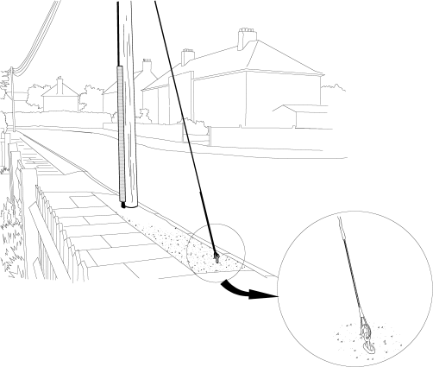

Figure 2:

* Figure 2 – above shows an example of a stay on an urban footpath, and how both the anchor and the stay wire itself, can present a risk to pedestrians and other road users.

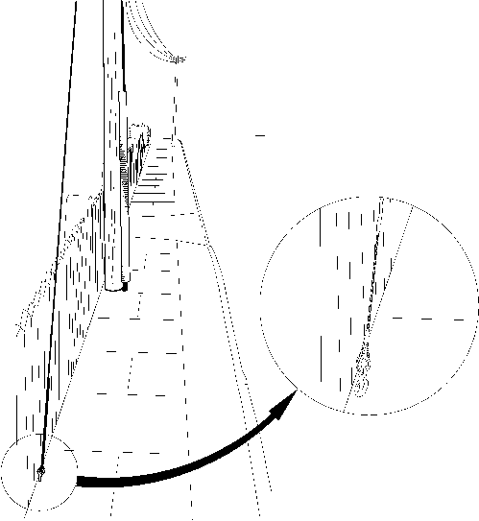

Figure 3:

* Figure 3 above - shows how if the pole and stay are positioned on the fence-line or house border side of the footpath, it presents a much reduced risk.

## Recovery of an Existing Strut

When identified by the works originator as being no longer required, existing struts shall be recovered and disposed of by the Work Executioner by an agreed method compliant with the Work Originator’s policy.

## Temporary Staying of Route

Where required the Work Executioner will be responsible for the temporary staying of any pole carrying the additional loads created by the temporary removal of the stay or other poles etc, along the route.

## Pole holes

* Where a pole is planted next to an existing pole the butt of the old pole must not be left in situ.

## Pole depths

The depth at which a pole is to be set in the ground varies with the character of the soil. Under average conditions (ie all soil conditions except poor ones), poles must normally be set to a depth of from 1.2 metres to 1.8 metres according to their length (ie 6 m 1.2, 15 m 1.8, all pole lengths in- between in proportion, see table 1 below).

In "made up ground" or where the soil is exceptionally loose (poor ground), increased depths must be allowed. See table below.

Poles classified as DPs are planted deeper than route poles. This is to allow for any unplanned out of balance loading. It is usually 300mm in normal or good soil, and 600mm in poor soil – however refer to tables below for specific depths.

Poles which were classified as route poles at the time of installation but which are subsequently changed to DPs do not require to be re-installed at greater depth. If the pole has an excessive out of balance load, which subsequently leads to lean beyond 10º, then the pole should be reported via A1024 for remedial action.

Poles must be set at adequate depth to ensure stability of the pole in the ground with the following aspects taken into consideration:

* Site conditions at the pole hole location
* Changes in ground level adjacent to the Pole
* Maximum load capacity of the pole (See EPT/ANS/A011 for details on Pole Loading Capacity)
* Any additional minimum depth set by the work originator.

### Poles in Banks/Slopes

Increased depths must also be allowed where poles are set in banks, since there would be a liability of the side of the bank giving way under heavy stresses.

Poles should be set to the depths identified in this document. However, when poles are set into the side or near the edge of banks or ditches it should be ensured they are set at adequate depth by additionally taking into account the slope and nature of the ground.

As a guide, when a pole is set at adequate depth, a line drawn from a point on the pole at ground level, to a position of no more than 45° to a horizontal line from the pole butt would always be contained in the undisturbed soil of the bank (see Figure 4, 5 and 6). A 1:1 base to height ratio would achieve this. This assumes the pole is in reasonably drained, well compact, undisturbed ground.



Figure 4: Pole set on 450 of bank



Figure 5: Pole set within 450 of bank



Figure 6: Poles set greater than 450 of bank

Additionally the following should be taken into account when considering the slope and stability of the bank:

If the pole is in soft or wet ground or a bank or ditch has been dug out and backfilled the maximum slope angle should be much less than 1 in 1 (see Figure 7). A maximum of 1 in 2 (25°) is a guide; and for very soft or very wet ground (for example marshy) it may have to be as low as 1 in 4 (15°).



Figure 7: Pole set in soft or wet ground

If the pole is set in long established undisturbed, very stable soil, or the bank/ ditch side is supported in some way (see Figure 8), then the angle may be greater than 45°. For example, some steep banks in rural lanes in the south west of the UK are very old and very stable.



Figure 8: Bank supported by retaining wall

* Do not allow for any stability from cables or stays when assessing the planting depth of a new pole.
* Particular attention should be paid to any features which may change, such as ditches which may be dug out.
* The ladder position of anyone climbing the pole cannot be assumed to add to the stability of the pole. The person may turn on the pole and tension wires away from the ladder.
* Any unsupported pull-on-pole may decrease the stability of a pole set in a slope by causing gradual failure of the supporting soil over time due to fluctuating loads. This may be made worse if the pull is trying to lever the top of the pole out of the bank.

### Standard Planting Depths for Wood Poles

For audit purposes the depths in Table 1 will be taken as the minimum. The depths should not be exceeded by more than 150mm. This is to ensure that cable clearance heights are not unduly affected. If it is necessary to replace spoil in a pole hole prior to planting, to comply with the above, ensure it is fully compacted.

* Wood poles which are to be used as distribution points must be set at least 1.5m in to the ground.
* For hollow poles, the depth in the ground shall be 1.5m (top of door aperture 1.6m above ground level).
* UNDER NO CIRCUMSTANCES SHALL THE BUTT END OF ANY POLE BE SHORTENED OR MODIFIED EXCEPT FOR AN APPROVED SLOT WHEN FITTING A BLOCK.

|  |  |  |  |
| --- | --- | --- | --- |
| Pole Length | Route or stayed poles in good or average soil conditions | DPs or equivalent poles in good or average soil conditions, or Route or Stayed Poles in poor conditions | DPs or equivalent poles in poor soil conditions |
| 6 | 1.2 | 1.5 | 1.8 |
| 7 | 1.3 | 1.6 | 1.9 |
| 8 | 1.35 | 1.65 | 1.95 |
| 9 | 1.4 | 1.7 | 2.0 |
| 10 | 1.5 | 1.8 | 2.1 |
| 11 | 1.55 | 1.85 | 2.15 |
| 12 | 1.6 | 1.9 | 2.2 |
| 13 | 1.7 | 2.0 | 2.3 |
| 14 | 1.75 | 2.05 | 2.35 |
| 15 | 1.8 | 2.1 | 2.4 |

Table 1: Standard Planting Depths for wood poles

Poor soil is:

Soft clay, clay loam, poorly compacted sand, clay containing a large amount of silt and vegetable matter, made up ground etc. Poor soils often have poor drainage and may be wet.

### Exceptions to Standard Pole Depths (Hand dug Poles in Urban Area’s)

Guidelines for use of alternative planting depths:

* The depths detailed here are ONLY applicable where the pole hole has been manually dug.
* In ALL instances where the mechanical auger has been deployed, the original depths must be adhered to.
* There are now 2 tables, one for Light poles, and one for Medium poles
* It is necessary to continue to determine the ground/soil conditions, but the number of categories has increased from 2 to 3. These are now "Good", "Average" and "Poor". (see definitions below)
* Account must be taken of the nature of the buildings, and as these revised depths are only to be used in urban situations, there are only 2 categories, terraced buildings (ie with little or no gaps between) or semi-detached.

1. See separate section for poles in Scotland.

Definition of urban:

Part of a Town, City or other large conurbation which has a reasonable density of population and is located in a generally low lying or unexposed area of the UK.

Soil / Ground Classifications

|  |  |
| --- | --- |
| Good | Compact, well graded sand and gravel, hard clay, well graded fine and coarse sand, decomposed granite, rock and soil. Good ground conditions should be well drained and in locations where water will not stand |
| Average | Compact fine sand, medium clay, compact well drained sandy loam, loose coarse sand and gravel. Average ground conditions should drain sufficiently well that water does not stand on the surface. |
| Poor | Soft clay, clay loam, poorly compacted sand, clays containing a large amount of silt and vegetable matter, and made up ground. Poor ground conditions will normally be wet and have poor drainage. |

Table 2: Soil / Ground Classifications

|  |  |  |  |  |  |  |
| --- | --- | --- | --- | --- | --- | --- |
| Light Poles | | | | | | |
| Pole Size | Route Pole in Urban Area | Route Pole in Urban Area | DP in "Terraced" type road <15m | DP in "Terraced" type road <15m | DP in Suburban Semi –Detached type road | DP in Suburban Semi –Detached type road |
|  | Good Soil | Average Soil | Good Soil | Average Soil | Good Soil | Average Soil |
| 6 | 1.2 | 1.2 | 1.3 | 1.3 | 1.2 | 1.3 |
| 7 | 1.2 | 1.3 | 1.3 | 1.4 | 1.3 | 1.4 |
| 8 | 1.2 | 1.3 | 1.4 | 1.5 | 1.4 | 1.5 |
| 9 | 1.3 | 1.4 | 1.4 | 1.5 | 1.4 | 1.5 |
| 10 | 1.3 | 1.4 | 1.5 | 1.6 | 1.5 | 1.6 |
| 11 | 1.4 | 1.5 | 1.6 | 1.6 | 1.6 | 1.7 |
| 13 | 1.5 | 1.6 | 1.7 | 1.8 | 1.7 | 1.8 |
|  |  |  |  |  |  |  |
| For Poor Soil (see definition) add 300mm in all cases | | | | | | |

Table 3: Exceptional Pole Depths (Light Poles)

|  |  |  |  |  |  |  |
| --- | --- | --- | --- | --- | --- | --- |
| Medium Poles | | | | | | |
| Pole Size | Route Pole in Urban Area | Route Pole in Urban Area | DP in "Terraced" type road <15m | DP in "Terraced" type road <15m | DP in Suburban Semi –Detached type road | DP in Suburban Semi –Detached type road |
|  | Good Soil | Average Soil | Good Soil | Average Soil | Good Soil | Average Soil |
| 7 | 1.2 | 1.3 | 1.3 | 1.4 | 1.3 | 1.4 |
| 8 | 1.3 | 1.3 | 1.4 | 1.5 | 1.4 | 1.5 |
| 9 | 1.3 | 1.4 | 1.4 | 1.6 | 1.4 | 1.5 |
| 10 | 1.4 | 1.5 | 1.5 | 1.7 | 1.5 | 1.6 |
| 11 | 1.4 | 1.6 | 1.6 | 1.7 | 1.6 | 1.7 |
| 12 | 1.5 | 1.6 | 1.6 | 1.8 | 1.6 | 1.7 |
| 13 | 1.5 | 1.7 | 1.7 | 1.8 | 1.7 | 1.8 |
| 15 | 1.6 | 1.8 | 1.8 | 1.9 | 1.8 | 1.9 |
|  |  |  |  |  |  |  |
| For Poor Soil (see definition) add 300mm in all cases | | | | | | |

Table 4: Exceptional Pole Depths (Medium Poles)

Poles in Urban back gardens or similar urban locations, in Scotland or elsewhere in the UK.

For Poles in these situations, it is necessary to make an assessment of the degree of exposure. Any pole which is considered "exposed" must be planted to the standard depth. These revised depths listed below can only be for poles in "normal" or "sheltered" exposure. Again, these revised depths only apply where the pole is manually dug, if the auger is used, then the original depth applies. It is assumed that virtually all poles in these situations will be DPs.

Definitions

Local knowledge of the surrounding country will provide an indication of the appropriate classification to be used. In general, the three degrees of exposure will apply as follows:

1. Sheltered – Where nearby hills, buildings, woods or other features protect the line from high winds.
2. Normal – Inland situations where there is no significant shelter from winds.
3. Exposed – Situations near most of the UK coast and over higher ground, where winds of high velocity and/or icing are more likely to occur.

Where there is doubt as to the class of exposure, use the higher one.

|  |  |  |  |  |
| --- | --- | --- | --- | --- |
| Pole Size | Light Poles  "normal" or "sheltered" only | | Medium Poles  "normal" or "sheltered" only | |
|  | Up to 40m Garden Length | Up to 50m Garden Length | Up to 40m Garden Length | Up to 50m Garden Length |
| 6 | 1.3 | 1.4 |  |  |
| 7 | 1.4 | 1.5 | 1.4 | 1.5 |
| 8 | 1.4 | 1.5 | 1.4 | 1.5 |
| 9 | 1.4 | 1.5 | 1.5 | 1.6 |
| 10 | 1.5 | 1.6 | 1.5 | 1.6 |
| 11 | 1.5 | 1.6 | 1.6 | 1.7 |
| 12 |  |  | 1.6 | 1.7 |
|  |  |  |  |  |
| For poor soil (see definition) add 300mm in all cases | | | | |

Table 5: Revised Pole Depths – Urban "normal" or "sheltered"

Poles in Non Urban Situations – Rural or Exposed

All poles in non urban situations must still be planted to the Standard depths. In most cases it should be possible to use the auger, but EVEN IF THIS IS NOT POSSIBLE, then the hole will need to be manually dug to the original depths.

## Other Exceptions to Standard Depth – Restricted Depth

* Wood Poles

Wooden Poles set in rock sockets and in stable rock backfilled excavations may be stable when the depth of the pole in the rock is as little as 0.9 m. Reduced planting depths are allowed where the minimum planting depth of 1.2m is achieved, provided the following conditions are met:

* A minimum of 0.9M of the pole is in rock,
* The type of rock complies with the definitions shown below
* The pole is recorded on the national register of poles at restricted depth.

Please click  for the data capture form.

Once completed, the form should be sent tofollowing e mail address:-

“Poleupdate G” which is on the Global Address List

For further details, please contact the Pole test control Office on: 0800 0778935

### Hollow poles

These may be planted at reduced depth in accordance with the above conditions however the minimum planting depth shall be 1.35m - to prevent the cutaways for the UG feed being exposed.

### Definition of Rock

Three types of rock are found:

* Soft Rock – Means a bed of rock that may consist of a mass of hard stone containing fissures or seams; it not being practicable to excavate by fork and/or spade. Although it may be possible to excavate using an ordinary pickaxe, it would, if so excavated, result in a very uneconomical rate of progress and so necessitate the use of a compressor and pneumatic tools for economical excavation. Not withstanding the foregoing definition, soft stone (eg chalk etc) shall NOT be classed as rock where excavation is by means of a mechanical excavator/digger/pole erection unit.
* Hard Rock - Means a solid mass of rock which may have seams, but is virtually unaffected by a blow from a pickaxe, and requires a compressor or blasting equipment to execute excavation.
* Boulder rock - Means a solid stone in boulder formation, similar in character to hard rock, having a measurement exceeding 380mm cube or volume exceeding 0.055cubic metre (eg (380mm x 380mm x 380mm) or (300mm x 500mm x 390mm) or approximate imperial equivalent measurements (12" x 20" x 16").

## Pole depth verification

Conduit 20 & Plug Conduit 20

All wood poles shall be installed with a length of conduit down the side to allow for confirmation of compliance to depth and integrity regulations.

Conduit 20 is supplied in 2.3m lengths. Before attaching to the pole, this should be cut to length using a hacksaw so that approximately 150mm will be showing above the reinstatement.

The conduit 20 shall be fitted making sure that the bottom end is flush with the butt of the pole and the top end is accessible and will not interfere with any cable/duct feeding the pole or the earth wire (where fitted) and that the plugs are fitted top and bottom.

Five Staples Galvanised 65mm, equally spaced, should be used to secure the conduit to the pole. The top staple should be located 100mm from the end to allow removal of the plug. Care should be taken, when driving in the staples, not to crush or damage the conduit.

## Pole alignment & orientation

* Alignment

Poles shall be erected to ensure they are vertical when viewed from all angles. Vertical definition and permitted tolerances are defined in Appendix 6 - vertical definition & permitted tolerances.

### Orientation (Hollow poles)

When a hollow pole is placed adjacent to a kerb line, the door shall be positioned so that all work can be carried out on the footway. See Appendix 7 - hollow pole orientation.

When a pole is placed against a boundary wall or fence, the door shall be positioned facing outwards away from the wall or hedge line. See Appendix 7 - hollow pole orientation.

## Reinstatement

All reinstatements will be carried out in accordance with the New Roads and Street Works Act (NRSWA) and the associated Code of Practice titled Specification for the Reinstatement of Openings in Highways (ISBN 0-11-551143-1). This details the materials to be used and standards of workmanship that are to be adopted to achieve the prescribed requirements.

Apart from the surface reinstatement down to a minimum level to satisfy the code of practice, reinstatement around poles which are considered as surround to apparatus, should be with the material excavated or as near as possible a match to it. If the material removed cannot be replaced for any reason, match the existing ground as closely as possible.

Where the excavated spoil from around the Pole is too wet to compact, Soil Stabilizing Agent may be mixed with existing spoil to provide a suitable backfill material. Exceptionally, Type 1 Granular Sub Base may be used.

Do not use Limestone granular backfill.

## Possible Technical Departures From Standards (TDFS)

There will be possible instances where it is not possible, or cost effective, to fully comply with the relevant standards detailed in this document. In those cases, it MAY be possible to apply for a TDFS for a particular job. The process for this is detailed in EPT/ANS/A013.

## Statutory notices

When a new pole has been installed, an ‘objection to overhead apparatus’ form A273 must be attached to the pole within 3 days of completion of work.

If several dropwires are to be changed or added within the next 3 months, a form A273a must be attached.

The A273 shall be clearly annotated with the Date of works together with the name and contact details of the works executioner.

## Marking and Labelling of Poles

General – Marking and labelling of products will be in line with standard BT practice.

* Poles (DP’s & Carriers) shall be correctly numbered.
* All necessary labels (ie Hollow Pole No climb) shall be provided as necessary.
* Labels on Wooden Poles should be fixed between 1.9m – 3.0m above the ground line. The labels are attached to the pole with Pins Steel No 1 through the holes provided.
* Labels on Hollow Poles (self-adhesive) should be fitted at a height of approximately 1m above the top of the door aperture.
* Numbers / Labels / 3 metre mark shall be clearly visible on approach to the pole (not obscured in bushes etc)

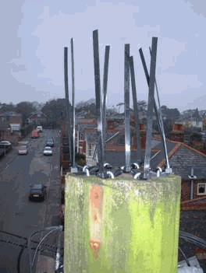

## Registration of New Poles

All new poles installed shall be registered as soon as possible on the Asset Assurance database. This is to ensure that details on pole population are captured soon after installation.

The process for this data capture is under review, but in the interim, the following data collection from can used. Click  for a copy of the form.

Once completed, it should be e mailed to:- [poleupdate@bt.com](mailto:poleupdate@bt.com)

For further details, please contact the Pole test control Office on: 0800 0778935

## Storage and Disposal of Poles

Environment Agency Groundwater Regulations consider the constituents of creosote used on Poles as hazardous. Left unchecked, potentially contaminated rain water running off from some pole stacks may enter and pollute controlled water sources. Openreach and its Contractors are therefore required to provide effective environmental management of their pole stacks to control the risk.

Within Openreach the risk is managed by the use of Pole Stack covers which prevent rainwater falling onto poles. Contractors may choose alternative options, but whatever thesolution, it must provide effective control of the risk.

All recovered poles shall be disposed of by the Works Executioner via an auditable process and in accordance with BT’s Environmental Policy and the Environmental Protection Act 1990.

The requirements for Pole disposal include, but are not limited to:

1. Recovered poles should have all BT markings, labels and fittings removed.
2. Poles which have been treated with green coloured copper chrome/arsenic preservative, or carry the markings B, BL, BX, P, TC, CE or C must not be sold as scrap or disposed of by burning. (See Appendix 8 - Preservative Treatments - Code Markings for details of each category.) These poles shall be disposed of by an agreed method compliant with BT policy. (See Appendix 8 - Preservative Treatments - Code Markingsfor preservative details.) Poles bearing an "EDT" label or having those letters carved into the timber should be reported to the Work Originator before disposal.

## Operating instructions

All products used will be fitted in line with the restrictions detailed previously and in line with the instructions issued with the kit to be used.

## Product approval

Only products approved by the SA shall be used.

# Requirements for Wireless Poles

Where the Pole being erected is to support an Antenna for a Point to Point, Wireless to the Cabinet (WTTC) application, specific requirements apply. These are fully detailed in ISIS - TMN/RSM/A141 and must be complied with.

The requirements for Poles which are to support other wireless applications i.e. Mobile Infil (MiiS) are fully detailed within EPT/ANS/A010.

# Appendices

## Appendix 1 - Universal Pole Bracket (UPB)

* Standard fixing to Pole is using Bolt Hex Head.
* When used on Hollow Poles and Joint User Poles, Stainless steel banding can be used to fix the bracket to the Pole.

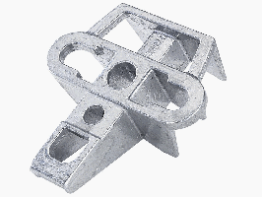

* See EPT/ANS/A012 for full details of plant attachment permutations.

## Appendix 2 - Lagging of Existing Poles in the Event of Bleeding

Hessian for lagging or wrapping poles (Untreated Hessian Cloth 36" wide) can be obtained from:

Phillip Stamp & Co Ltd  
Unit 2 Tollemache Business Park  
Offton, Ipswich  
Suffolk  
IP8 4RT

Tel - 01473 657770

E-Mail [sales@philipstamp.co.uk](mailto:sales@philipstamp.co.uk)

Dimensions and fixing positions of both the hessian and battens

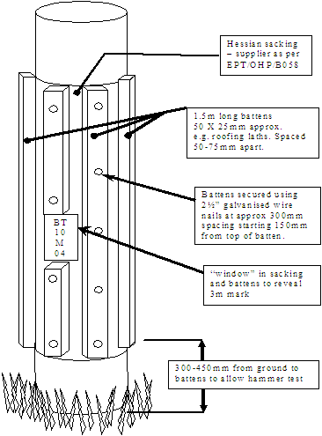

## Appendix 3 - Rings Polehead Dropwiring

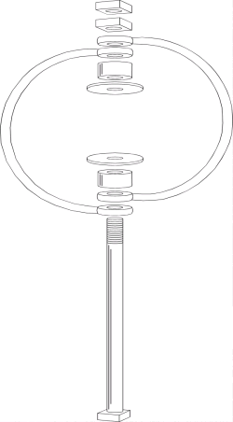

## Appendix 4 - Step Positions on Pole

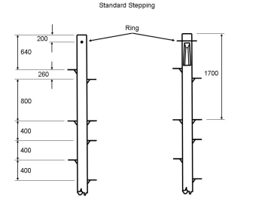

1. The position of Bass steps relative to climbing step

## Appendix 5 - Hollow Pole Caps and Collars

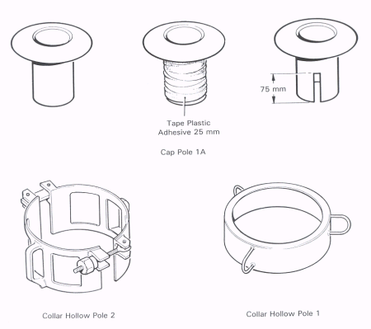

## Appendix 6 - vertical definition & permitted tolerances

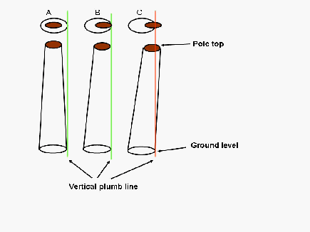

Figure A: Shows absolute vertical.

Figure B: The Pole alignment is moving away from true vertical but is still regarded as within acceptable tolerance.

Figure C: The top circumference has now moved beyond true vertical

For Quality Audit purposes: Any alignment between Figure A, up to and including Figure B is within acceptable tolerance.

Where, from any aspect, the top circumference is beyond the true vertical with respect to ground level circumference (ie Figure C). The alignment becomes outside of acceptable tolerance and should be regarded as below standard.

1. Any natural bend in pole between ground level & pole top to be allowed for in calculation.

## Appendix 7 - hollow pole orientation

Fig 1: Roadside

**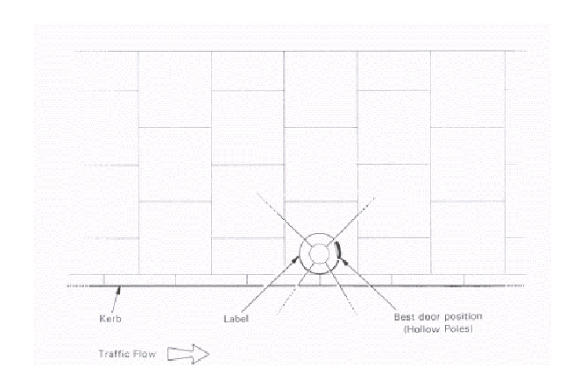**

Fig 2: Back of path against Wall or Hedge

**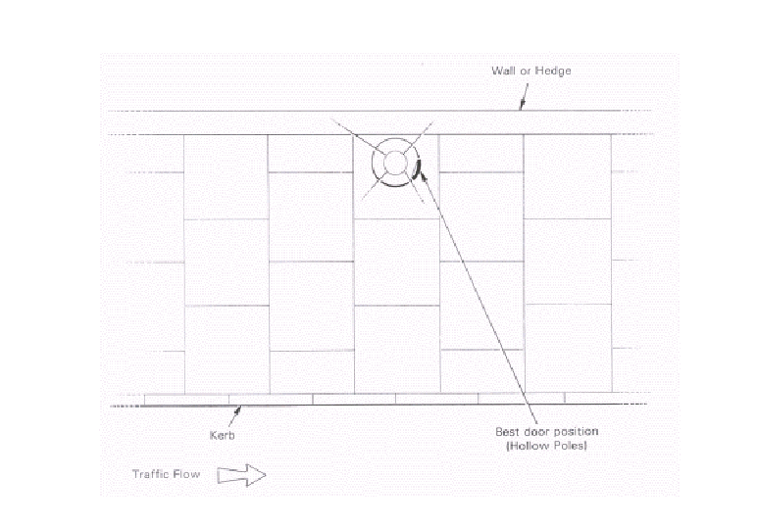**

## Appendix 8 - Preservative Treatments - Code Markings

|  |  |
| --- | --- |
| CODE | PRESERVATIVE |
| B or BL | Preserved with Wolman salts (Triolith 1930), Tanalith (1944 and 1947/8) |
| BX | Preserved with Wolman Salts and Fuel oil (1930) |
| C or CE | Preserved with Celcure |
| P | Preserved with Penta-chloro-phenol |
| TC | Preserved with Tanalith "C" (TC and TC1-5) |
| AC | Preserved with Osmose Nature Wood AC500 (Alternative preservative, pole appearance will have a greenish colour) |

END OF DOCUMENT